**Chapter 3: Displaying and Summarizing Quantitative Data**

Histogram: bar charts for quantitative data; usually data is grouped in equal-width bins

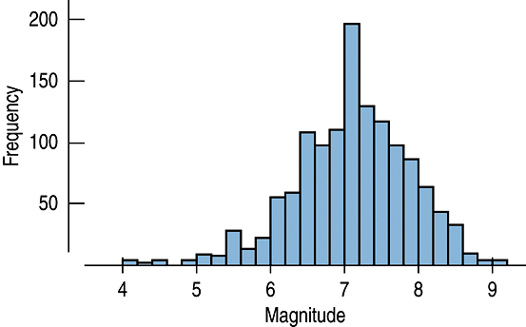

Stem-and-Leaf Display: visually like a histogram turned sideways; shows individual data values

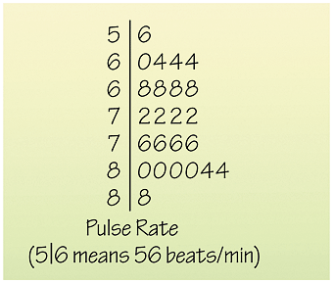

Dotplot: places a dot above an axis for each value in the data

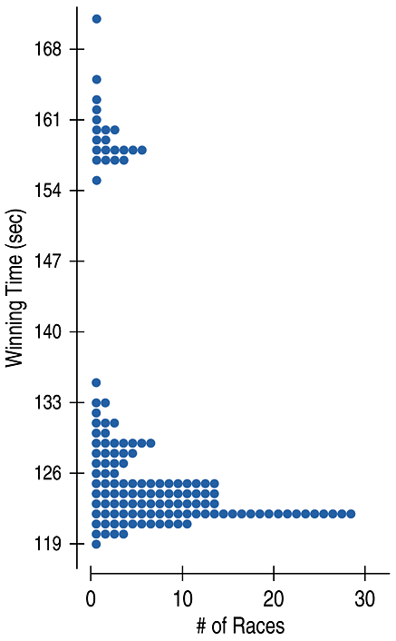

Any of these graphical displays show the **distribution** of the data. A distribution is described by:

1. Shape
   1. Modes (unimodal, bimodal, or multimodal) or uniform
   2. Symmetric or skewed
   3. Outliers
2. Center
   1. Mean $\overline{x}$  – sample mean
      1. More affected by extreme values*
   2. Median – after putting the data in ascending numerical order, the value “in the middle” of the data
      1. Odd number of data values – there will be an exact middle data value
      2. Even number of data values – median will be the average of the two middle data values
      3. less affected by extreme values*
3. Spread
   1. Range = max – min
      1. greatly affected by extreme values*
   2. Interquartile Range (IQR) = 

 is the first quartile and  is the third quartile. Find them by finding the median of each half of the data, respectively.

Less affected by extreme values*

* 1. Variance / Standard Deviation

$s^{2}$– sample variance

- sample standard deviation

More affected by extreme values*

*\*For symmetric data: Use mean and variance/standard deviation to describe\**

*\*For skewed data: Use median and IQR to describe\**

5-number summary

Minimum, Q1, Median, Q3, Maximum

Graph/Display of 5-number summary is a **boxplot**.

Can be drawn with either vertical or horizontal axis.

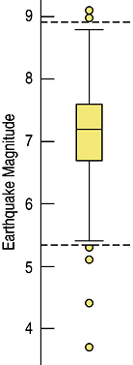

One way we can determine if we have **outliers** in our data is to calculate an “upper fence” and a “lower fence” using the IQR. Any data above the upper fence or below the lower fence is considered an outlier.

Upper fence = Q3 + (1.5)IQR

Lower fence = Q1 - (1.5)IQR





Variance of a: 77.95

Variance of b: 2.34